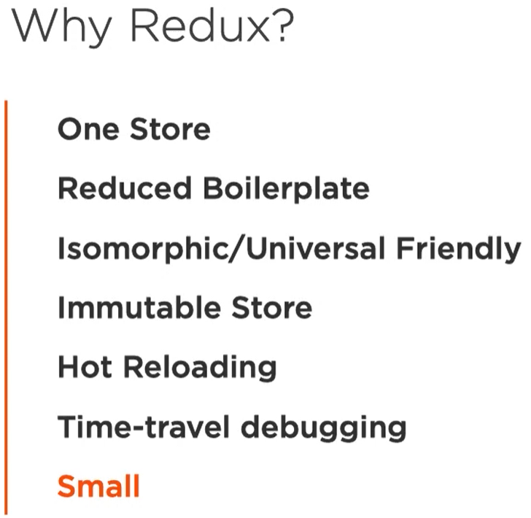

Environment Setup without create-react-app

To understand how **create-react-app** works.

Learn how to customize your dev environment.

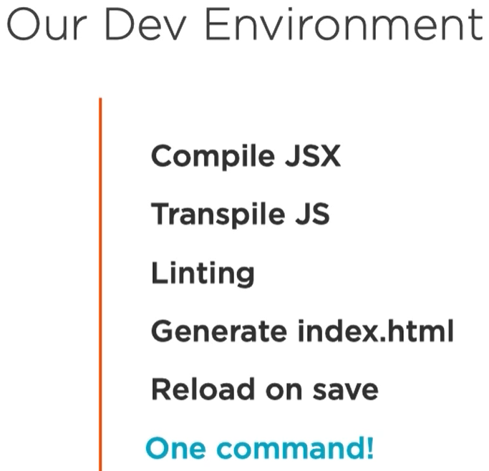 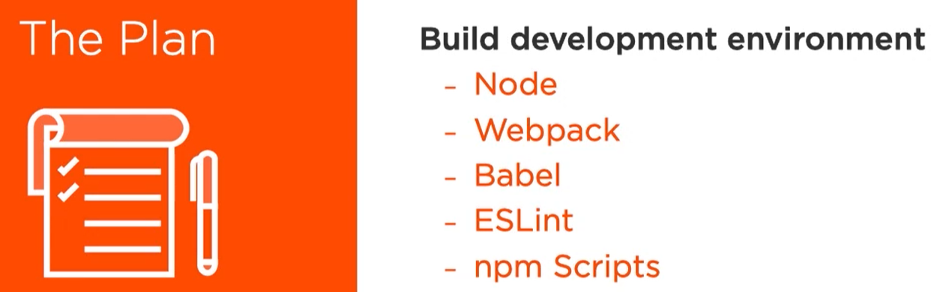

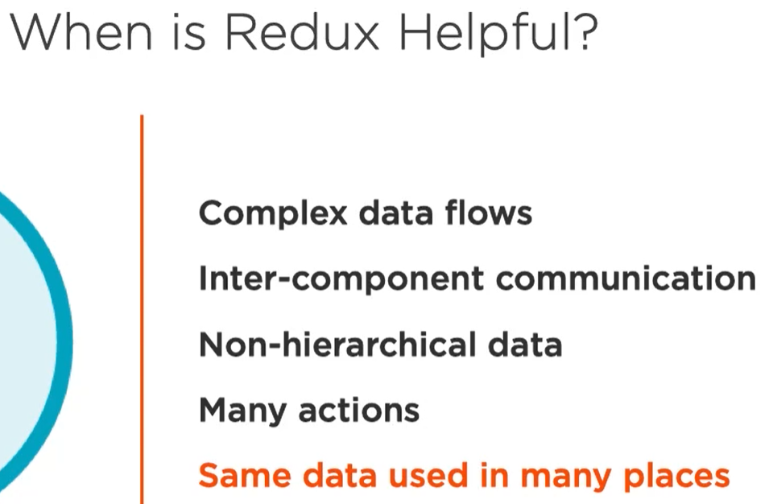

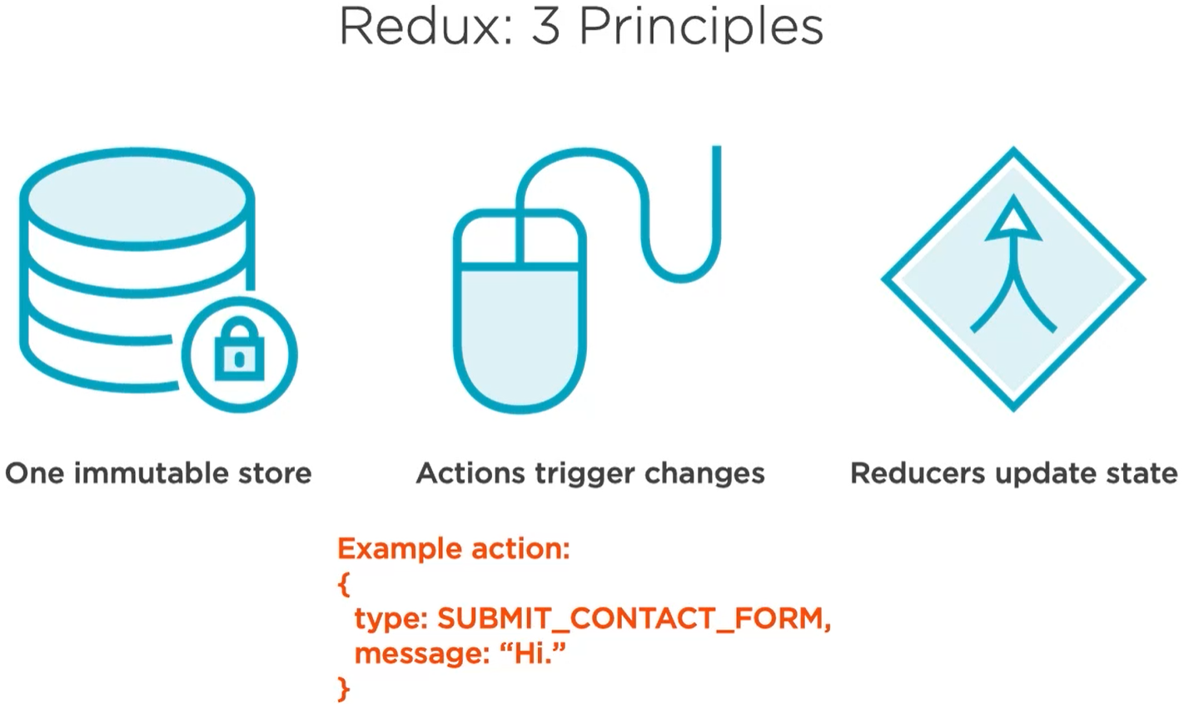

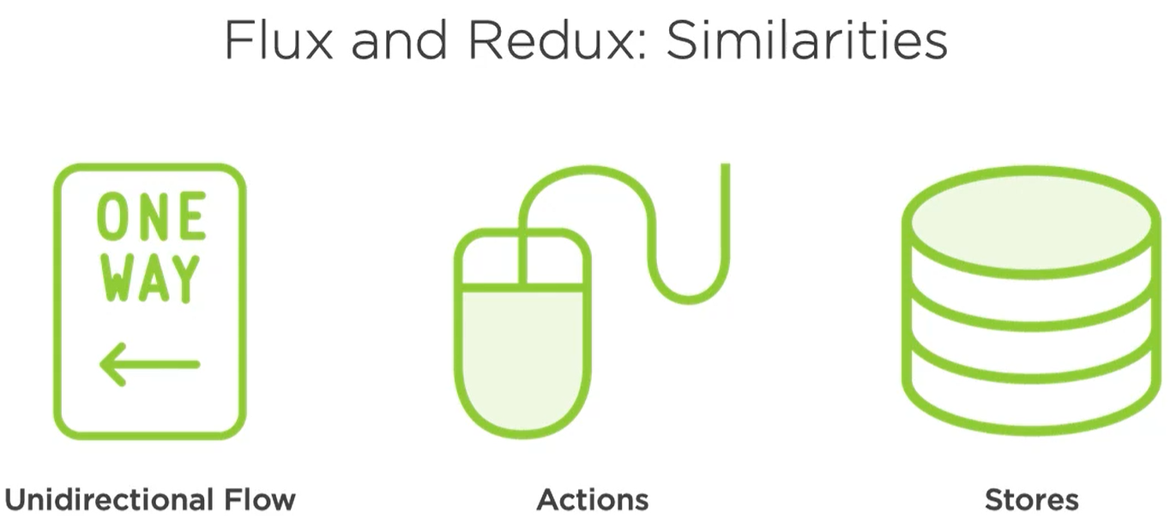

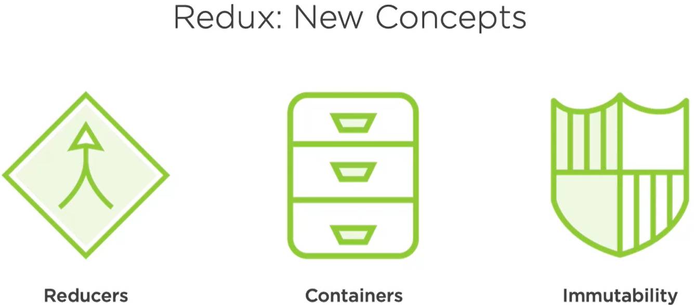

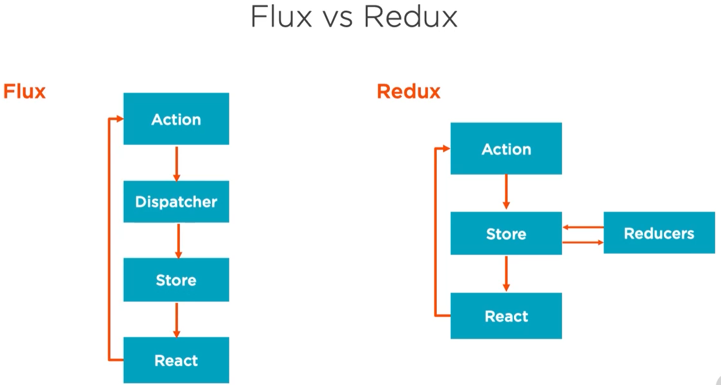

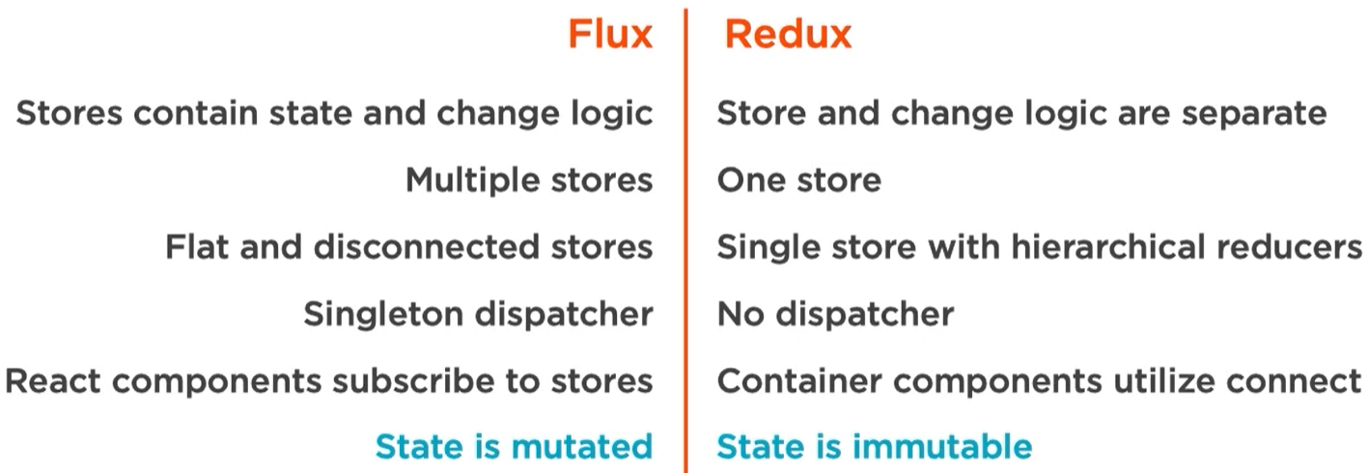

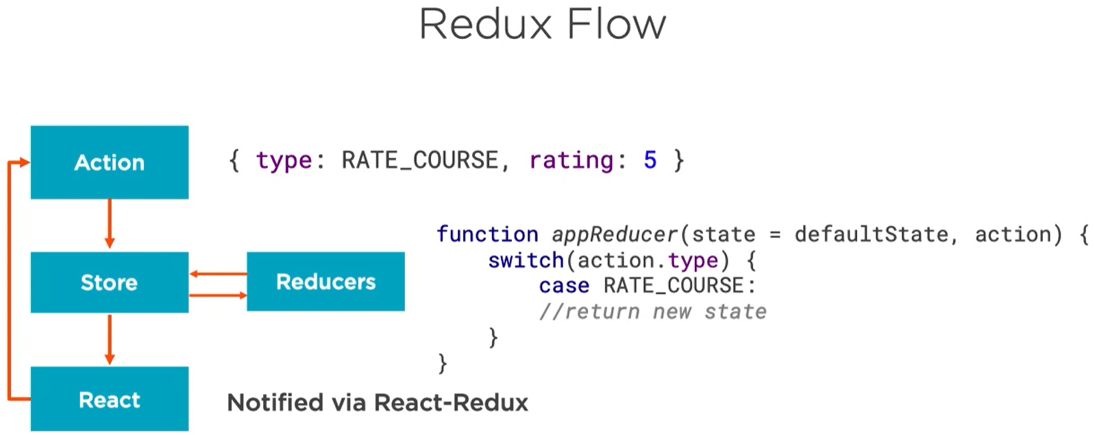

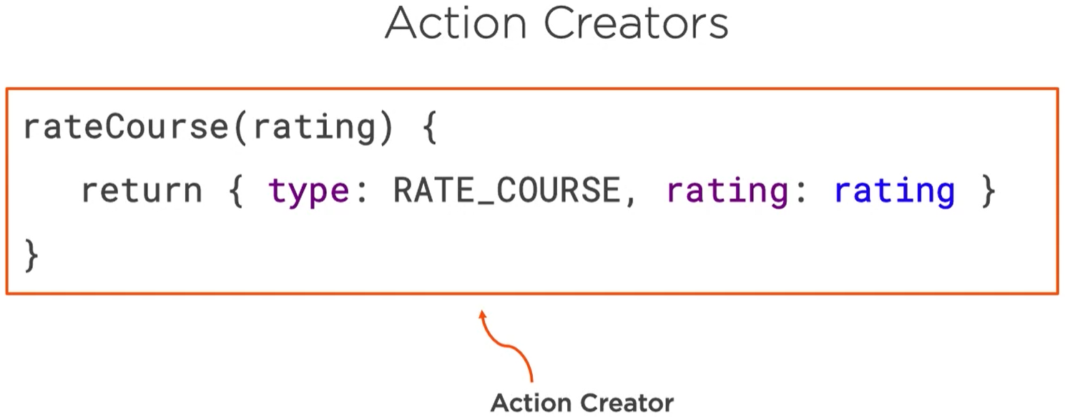

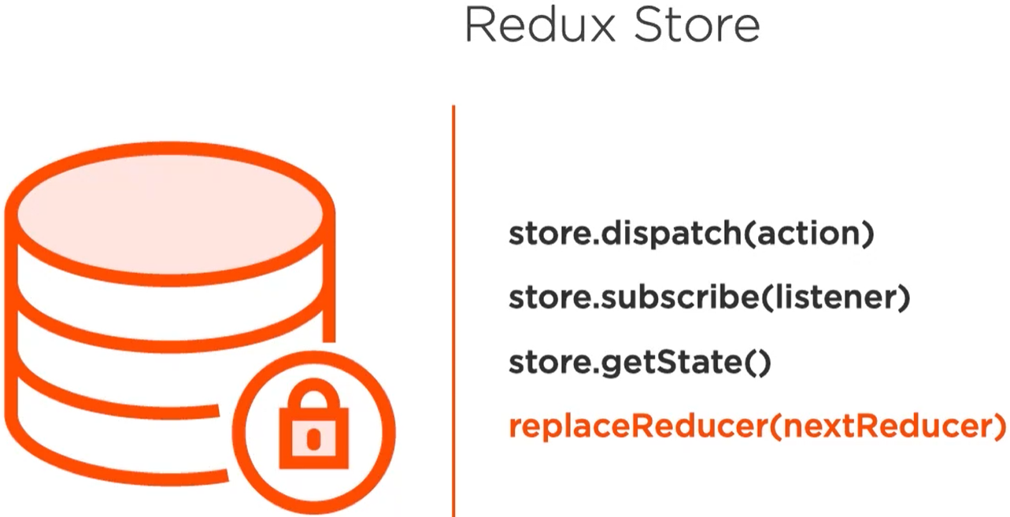

 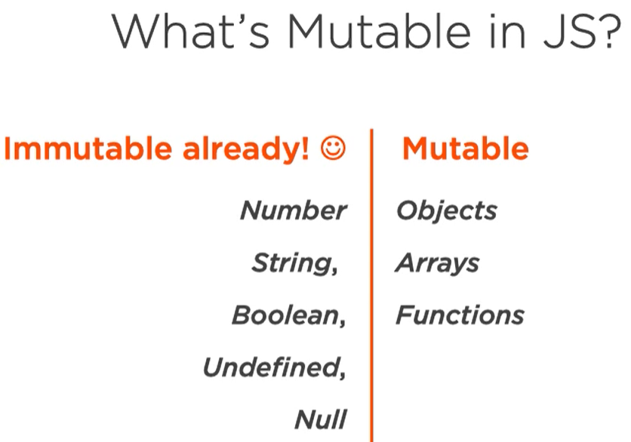

Handling immutable data in Js

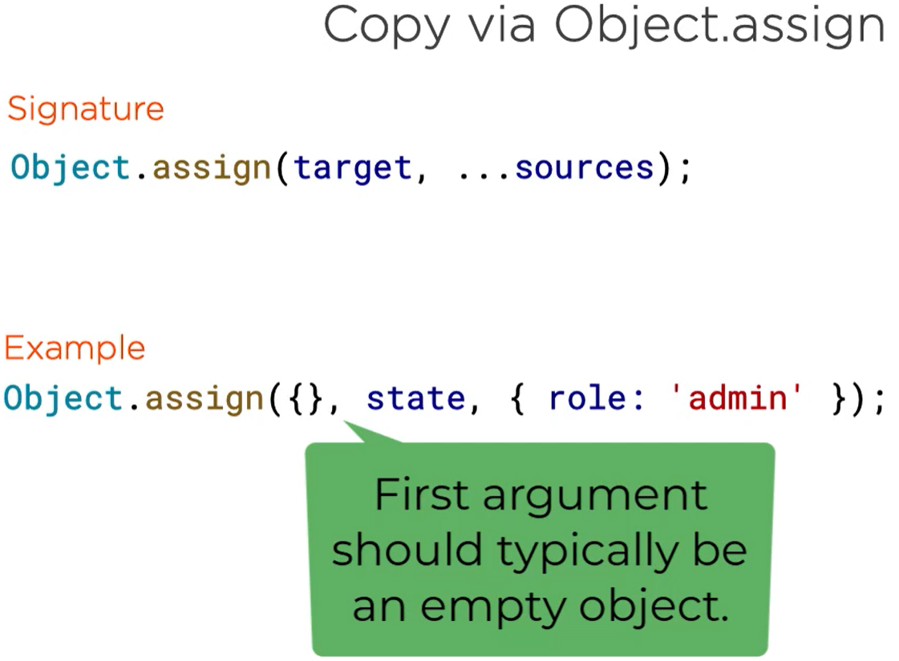

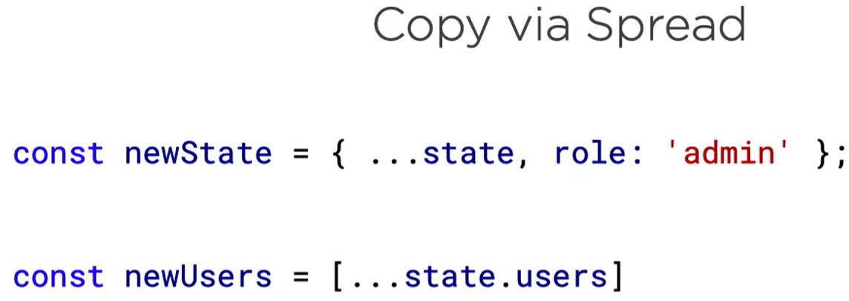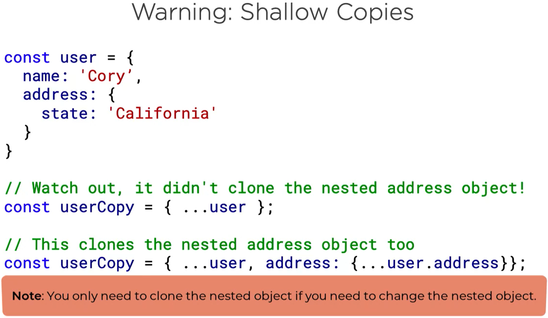

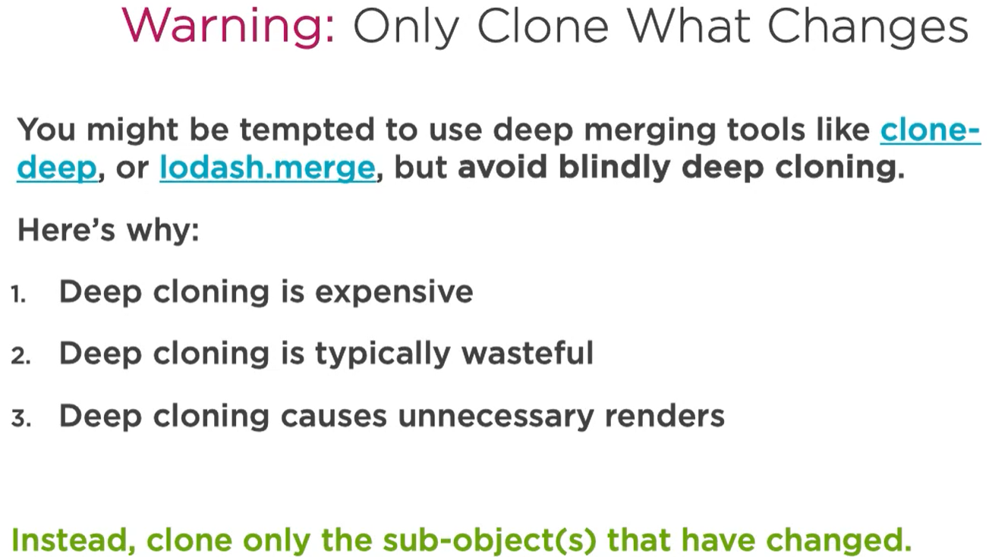

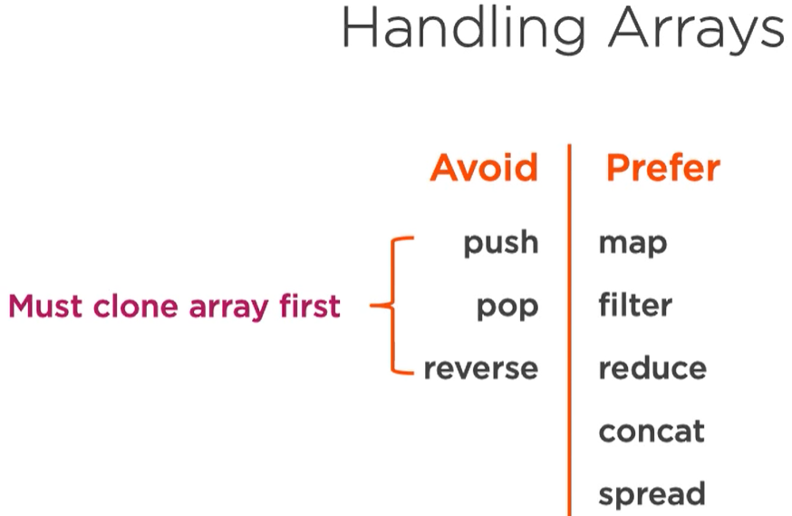

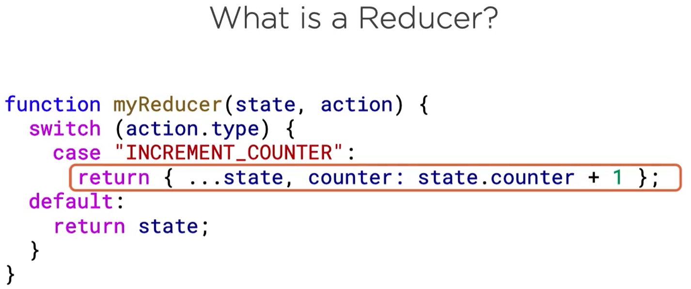

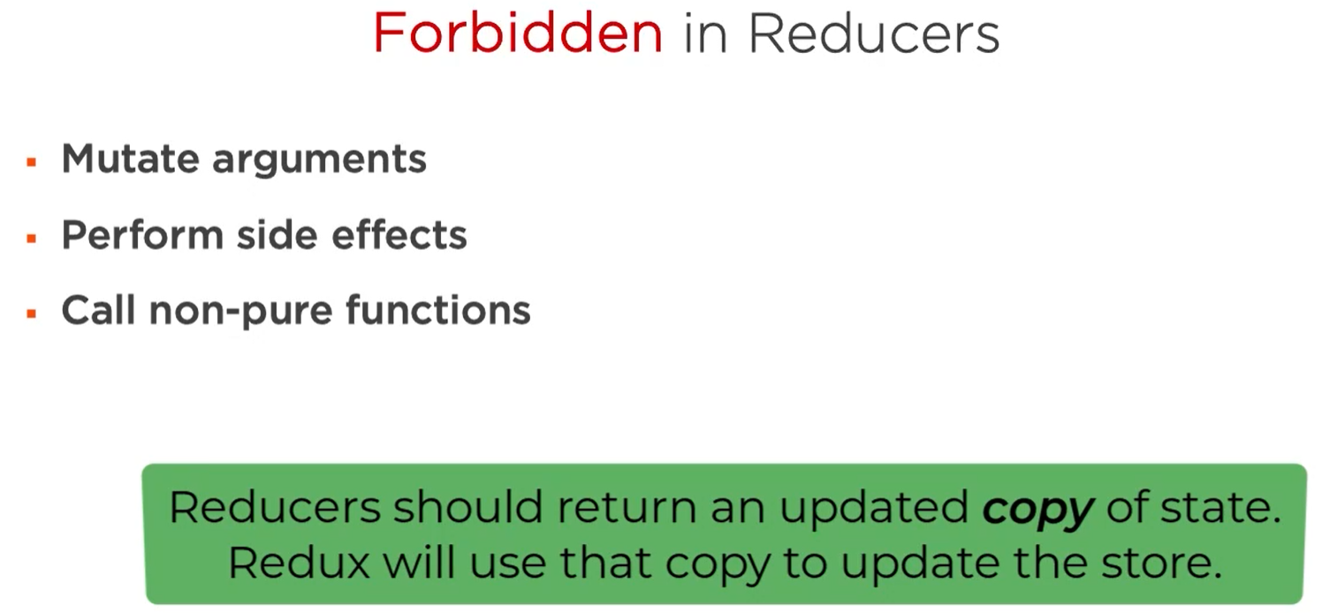

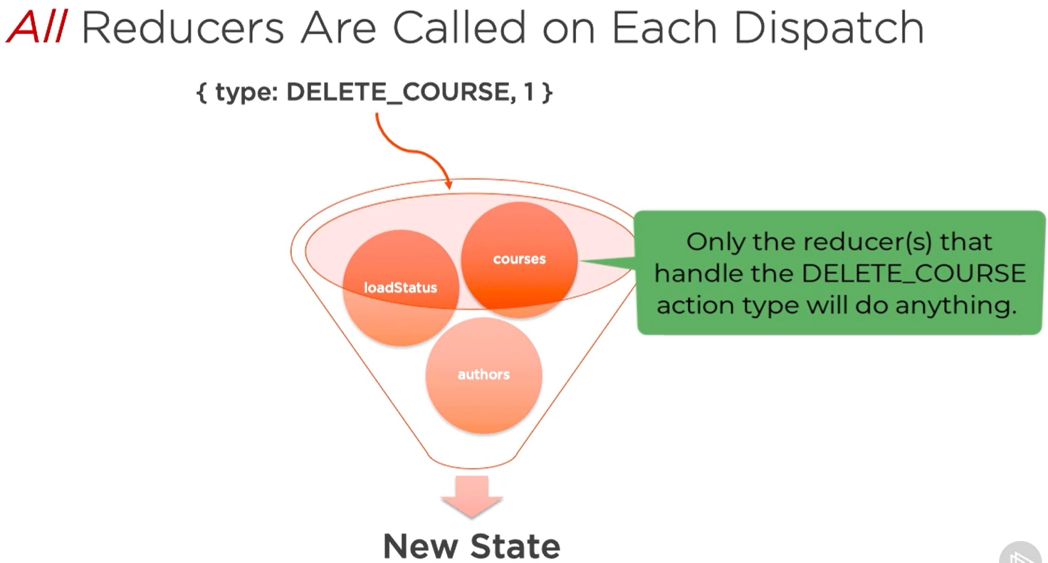

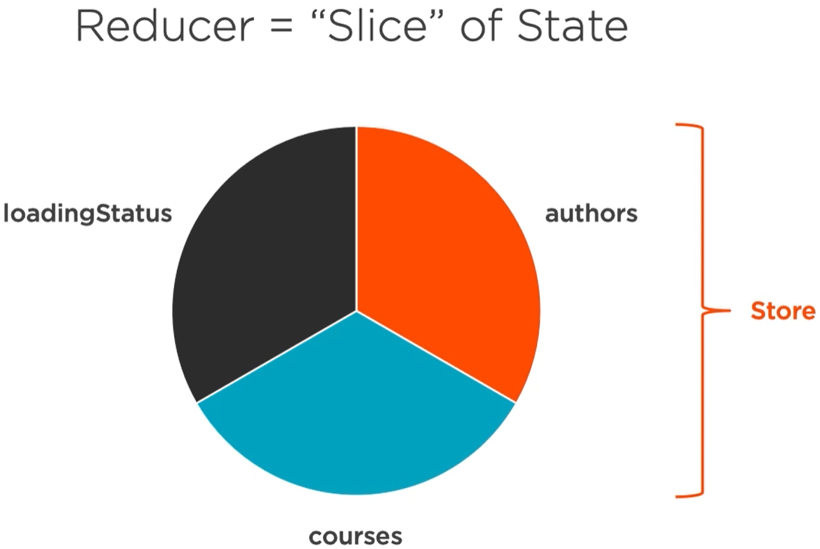 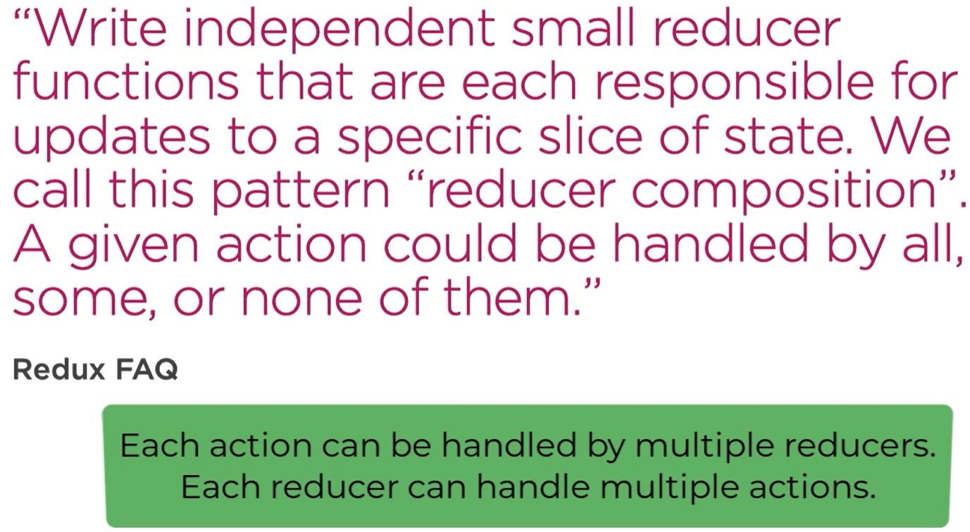

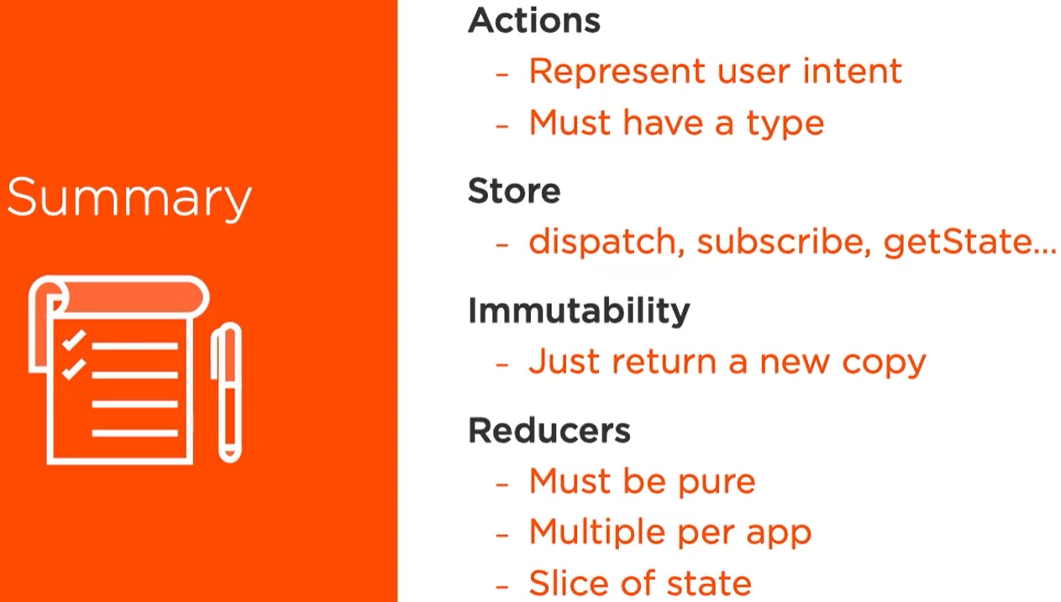

Connecting React to Redux

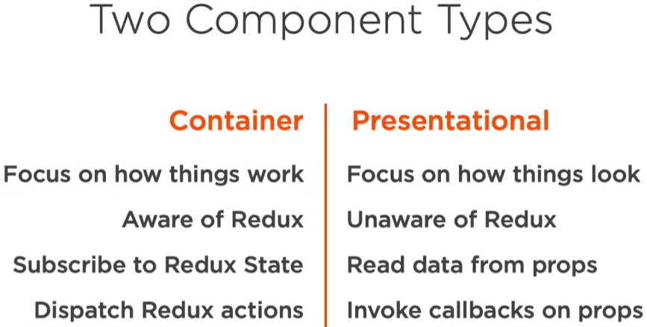

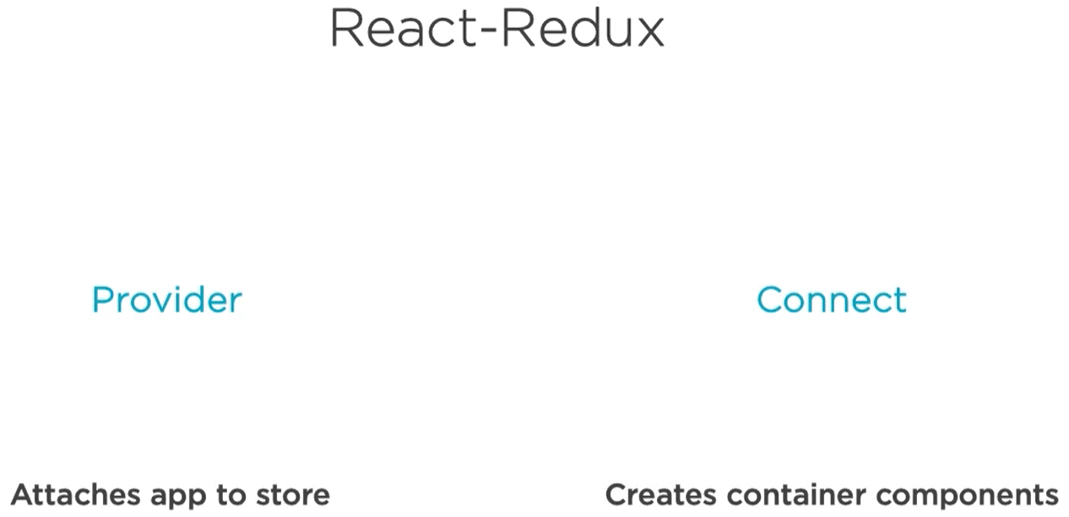

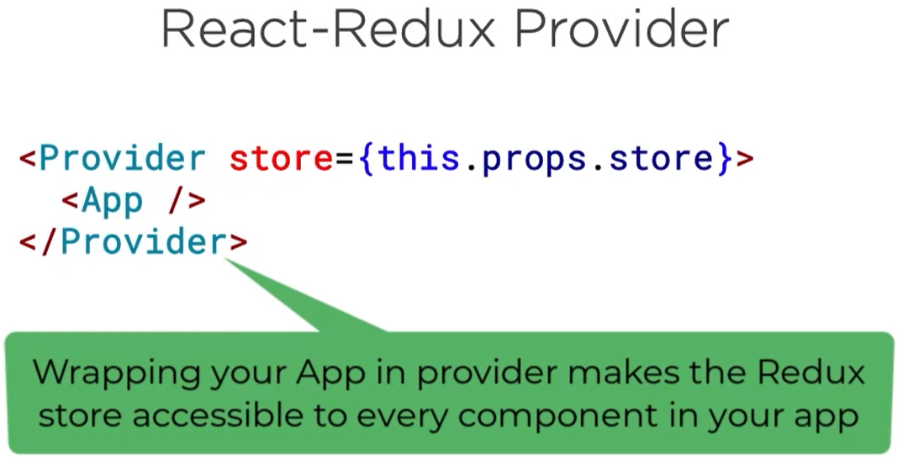

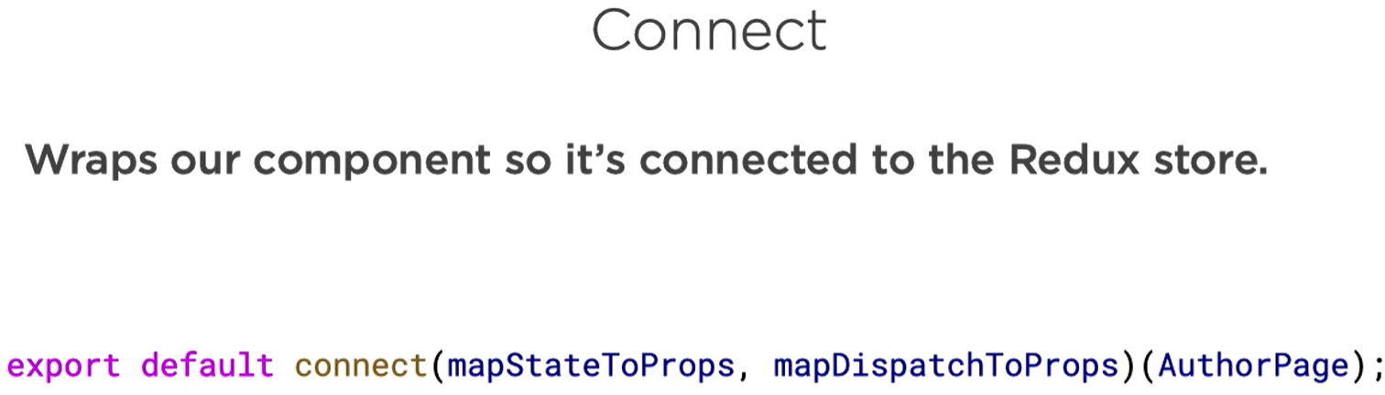

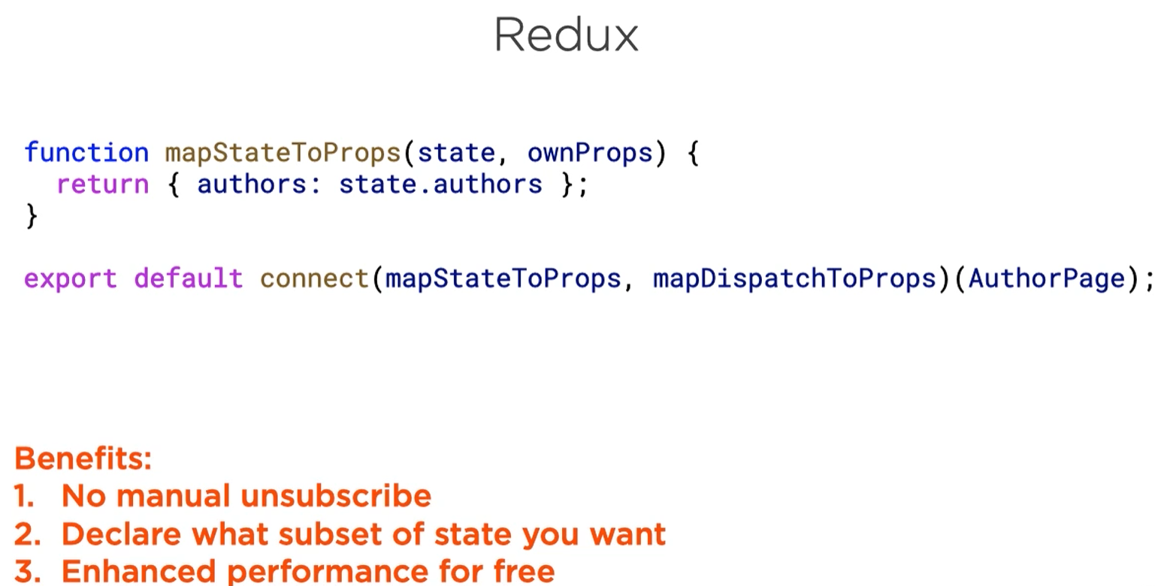

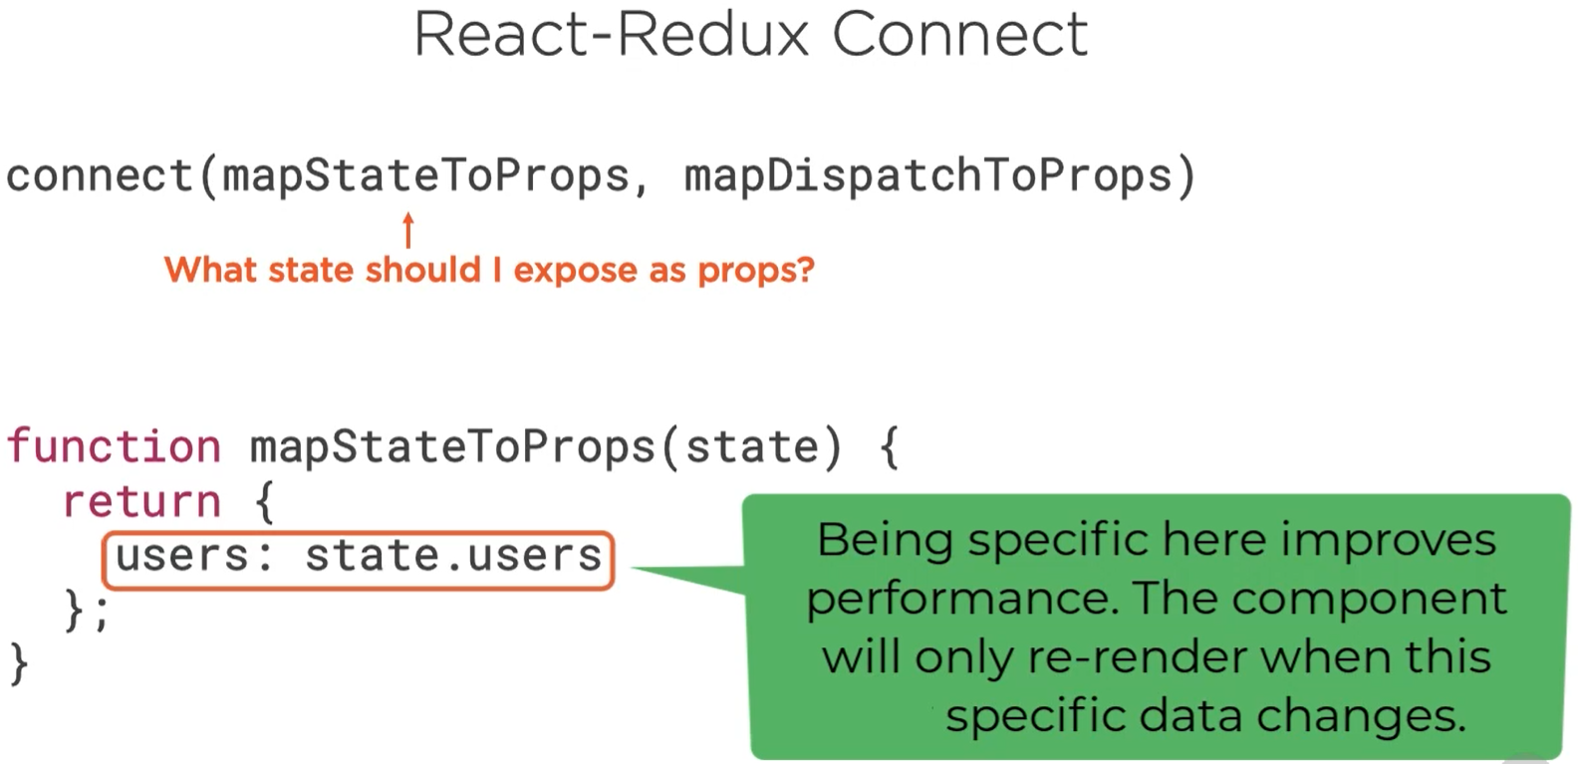

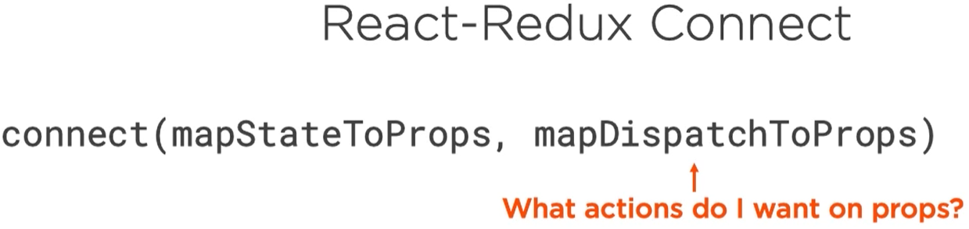

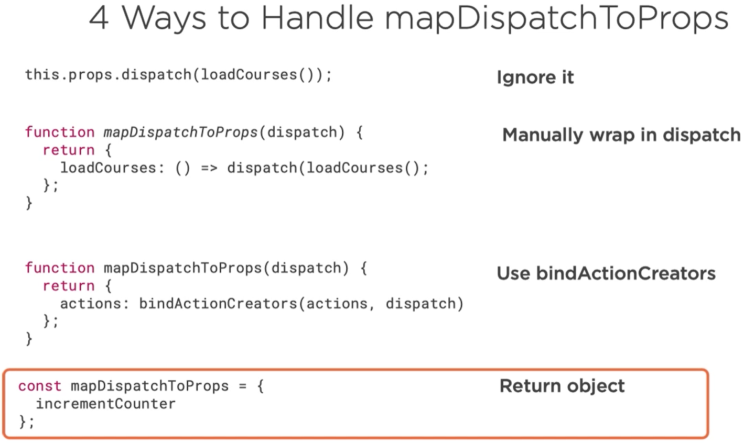

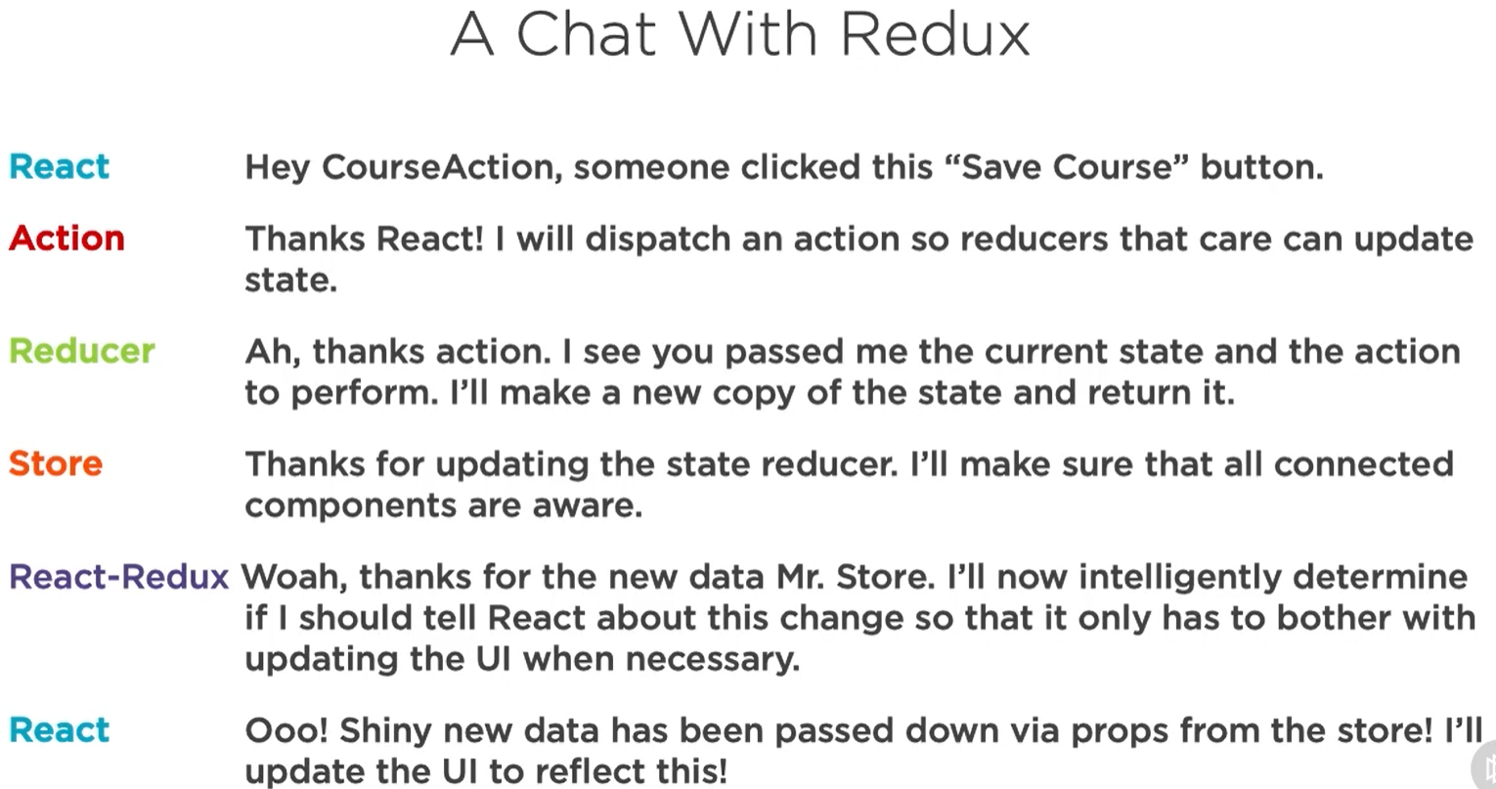

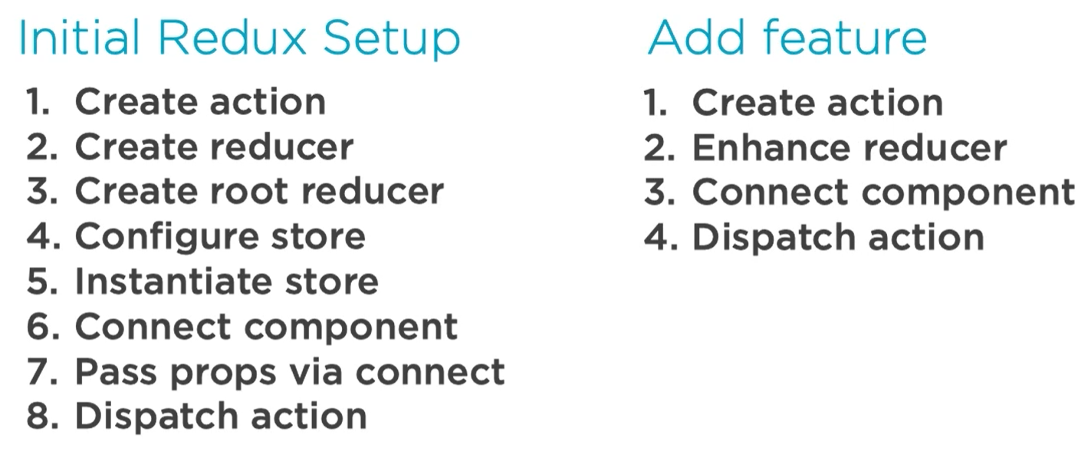

Async in Redux

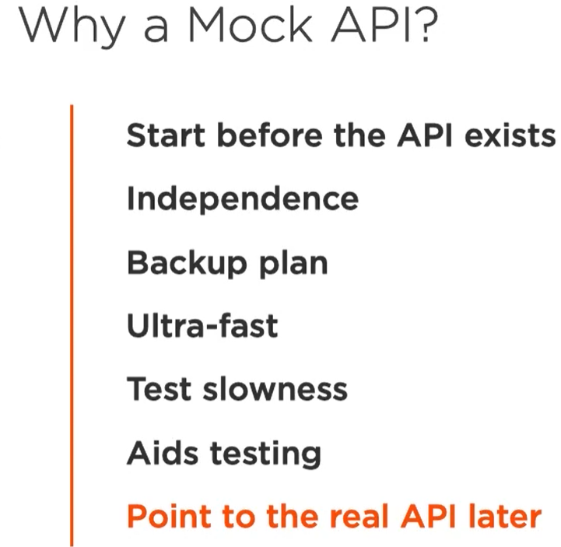

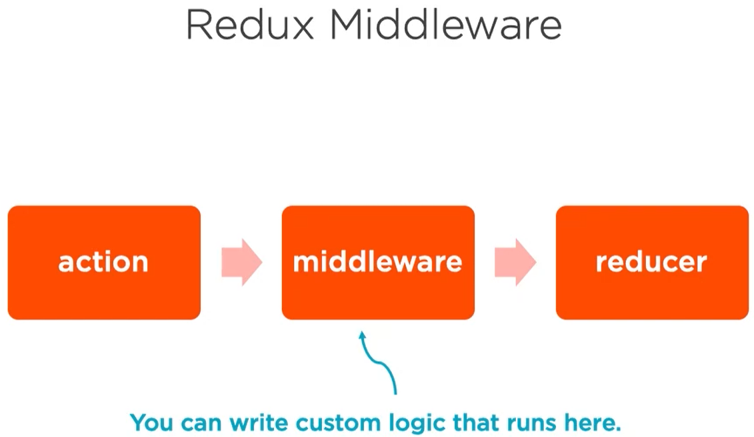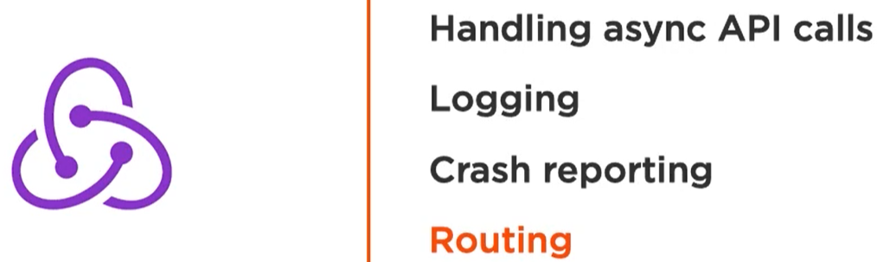

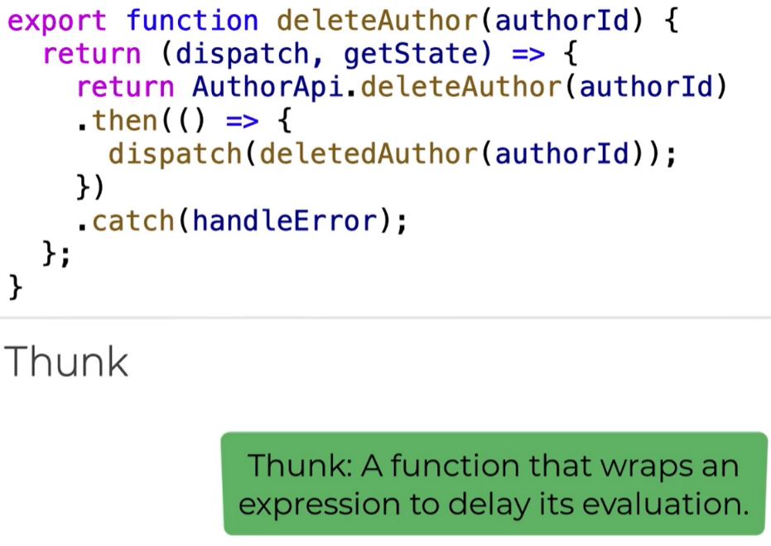 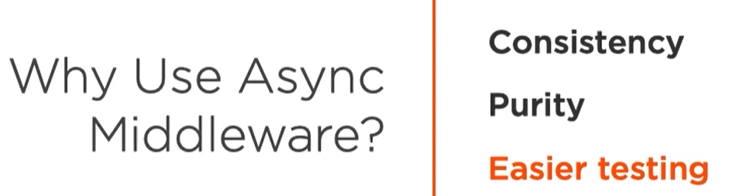

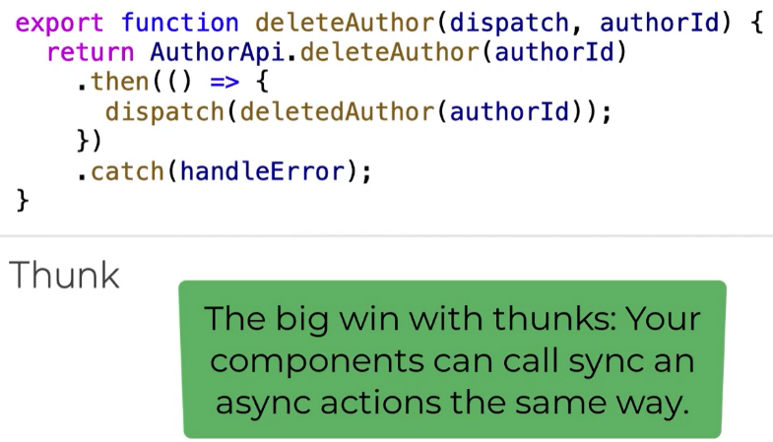

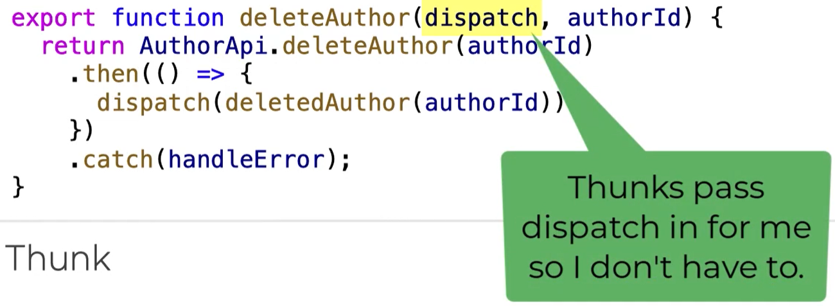

Testing using Jest

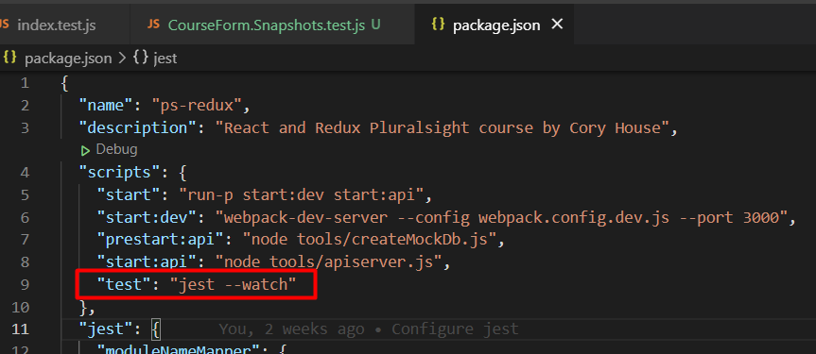

npm test

Jest and Enzyme are different but complimentary tools, that integrate well together to provide flexible and creative testing abilities. We will briefly look at the differences between the two.

Jest

*Jest is a JavaScript unit testing framework, used by Facebook to test services and React applications.*

CRA comes bundled with Jest; it does not need to be installed separately.

Jest acts as a**test runner**, **assertion library**, and **mocking library**.

Jest also provides **Snapshot testing**, the ability to create a rendered ‘snapshot’ of a component and compare it to a previously saved ‘snapshot’. The test will fail if the two do not match. Snapshots will be saved for you beside the test file that created them in an auto-generate __snapshots__ folder.

Enzyme

*Enzyme is a JavaScript Testing utility for React that makes it easier to assert, manipulate, and traverse your React Components’ output.*

Enzyme, created by Airbnb, adds some great additional utility methods for **rendering a component**(or multiple components), **finding elements**, and **interacting with elements**.

It must be installed in addition to tools already bundled with CRA.

Jest and Enzyme

* Both Jest and Enzyme are specifically designed to test React applications, Jest can be used with any other Javascript app but Enzyme only works with React.
* Jest can be used without Enzyme to render components and test with snapshots, Enzyme simply adds additional functionality.
* Enzyme can be used without Jest, however Enzyme **must** be paired with another test runner if Jest is not used.